Competitive Shooters of Lake Norman USPSA February 13th, 2026
COURSE DESIGNER: Rocky Perillo

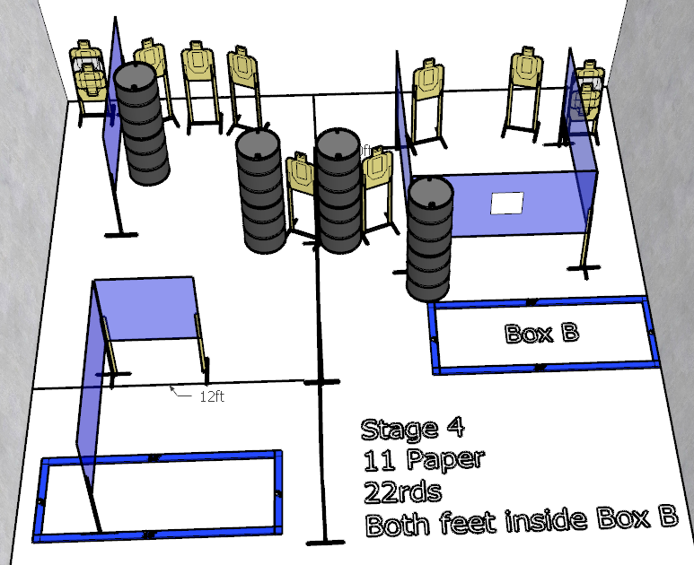

Stage 4 – Come on! Do it! Do it! Come on!
22 rounds, 110 points, Comstock
There are 11 cardboard targets with some no-shoots.
Starting with both feet inside Box B.
Handgun is loaded and holstered. Wrists above shoulders.
PCC is loaded, stock touching belt, strong hand wrist above shoulders.
On the audible start signal, engage targets from within the shooting area.

